**Object**

Building a fully functional six digit nixie tube clock with basic timing ability & possibly alarm capability. As a way to recall and value the long past age of vacuum tube and punch cards computers. It is capable of showing time as well as notifying its user at a certain time.

The product, as it stated, is a retro style clock and mainly interact with the environment with its timing feature as well as the feeling of displacement: I think it’s always fascinating to see something from the past being revived and fully functional at a time when most of its kind has lost in time long ago.

**Material & Components needed**

Arduino Board

PCB

Bread Board

Sufficient amount of Jump wires

4 Neon Light Blubs

6 IN-8 Nixie Tubes (Ships from Russia)

Tube shield

High voltage transistors

Capacitors

Etched mother board

Nixie driver

Nixie socket

Power Supply Unit

Decent casing

Buzzer

Extra USB connection port

Solder materials

*Planning on ordering most of the components needed

*Online material list attached as reference

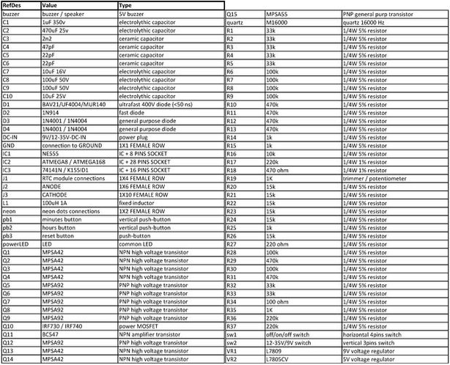

**Challenges**

The major challenge in this project is to sorting out all the required electronics as well as possibly math that come with them. As someone who hasn’t had any formal and serious education knowledge about specific type of hardware as well as a deep understanding on engineering experience, I anticipate some pretty serious challenges awaits. The most time consuming part in my project would be the construction of the circuit that retain all those functions described in previous section.

On the other hand, I would estimate that building an appropriate casing for the clock is a relatively easy job compare to what I need to do on the electronic part.

**Timeline**

* Week 1: Proposal Done
* Week 2: Learning basic electronic knowledge & waiting for materials
* Week 3: Testing assembly components
* Week 4: Final assembly & work on casing
* Week 5: Present!

**Reference Sites & Data Base**

[1]

<http://www.instructables.com/id/simple-user-adjustable-DIY-Nixie-Clock/?ALLSTEPS>

[2]

<http://mightydevices.com/?p=379>

[3]

<http://www.daliborfarny.com/>